**LOOMIO**

***“Threads of effort, woven into outcomes”***



**For the partial fulfillment of the requirements for the completion of the course - Software Engineering Practice (CS307)**

**SOFTWARE DESIGN DOCUMENT (SDD)**

**Team Members:**

**Y Sri Rama Bharadwaj – 123cs0030**

**J V Kousthub – 123cs0074**

**S Sai Videsh – 523cs0014**

**P Sanjay Davis – 123cs0031**

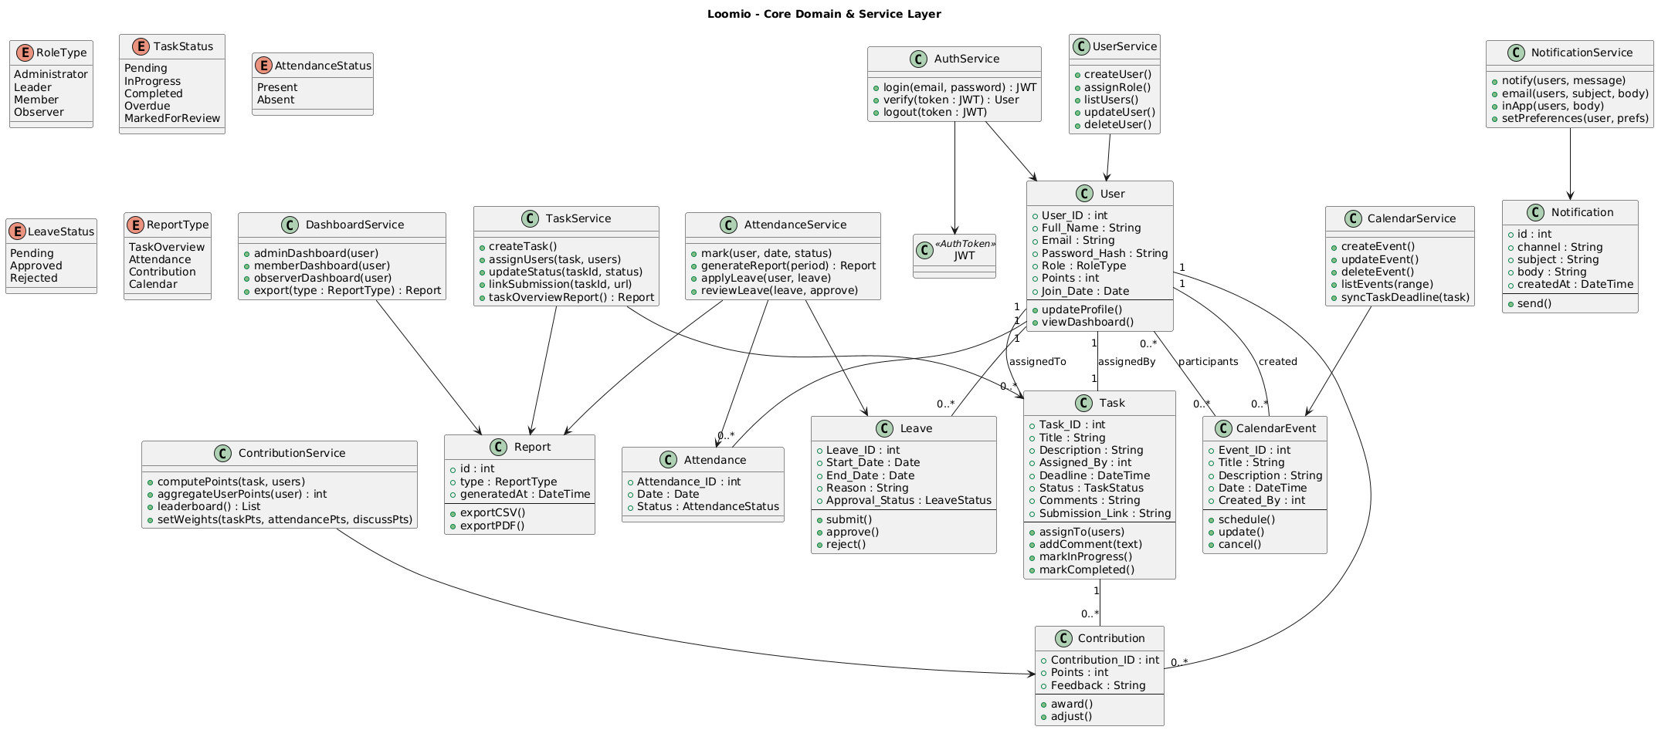**CLASS DIAGRAM**

This diagram depicts the logical structure of the Loomio, showing entities (User, Task, Contribution, Attendance, Leave, CalendarEvent, Notification, Report) and their relationships. It also illustrates supporting service classes which encapsulate the system’s functional modules as described in the SRS. Associations between users, tasks, events, and contributions reflect the primary data flows of the application.

**Use Case Diagram (Administrator / Leader)**

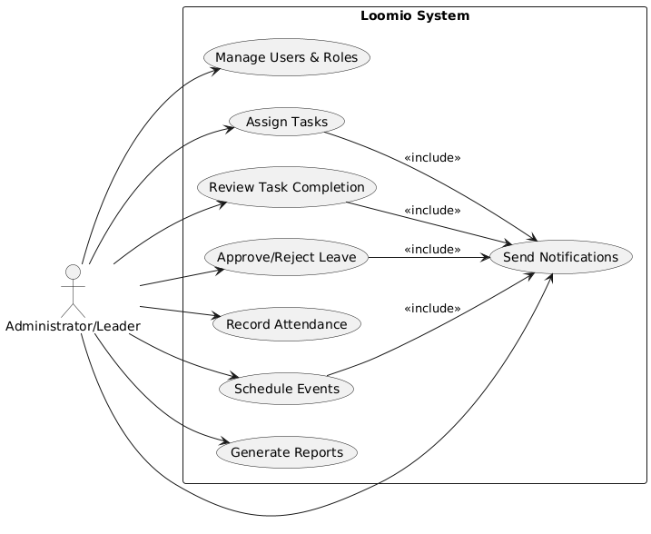

This diagram outlines the functional interactions available to administrators and leaders. It highlights capabilities such as managing users, assigning tasks, reviewing submissions, marking attendance, handling leave requests, scheduling events, configuring notifications, and generating reports. These align with the administrative and leadership modules specified in the SRS.

**Use Case Diagram (Member)**

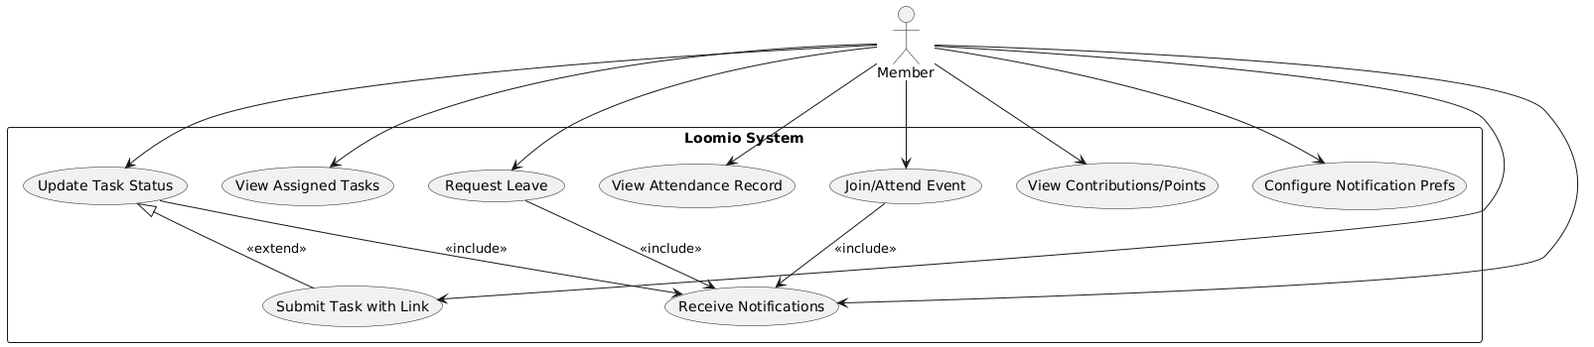

This diagram captures the actions that members can perform in the system. Members can register/login, update their profile, view and update tasks, confirm event attendance, request leave, and track both attendance and contribution summaries. They also receive notifications and view upcoming events, consistent with the member-focused requirements of the SRS

**Object Diagram (Task Assignment & Contributions)**

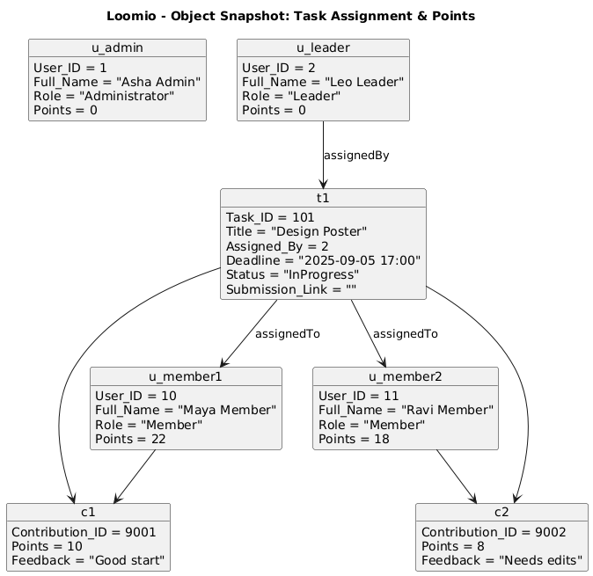

This runtime snapshot demonstrates how a leader assigns a task to multiple members, and how individual contributions are recorded against that task. Each member has earned contribution points and feedback for their work. This object model illustrates how the system dynamically manages assignments and calculates contributions in practice.

**Object Diagram (Attendance & Leave Workflow)**

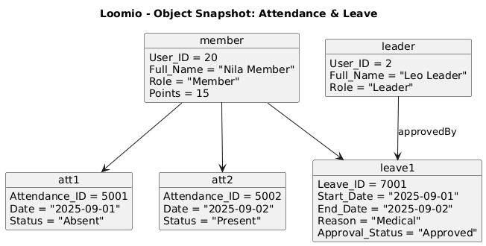

This snapshot models a member’s attendance records along with a submitted leave request. It shows how multiple attendance entries are logged for the same member, and how a leave request is approved by a leader. The diagram emphasizes the link between attendance management and leave processing in the system.

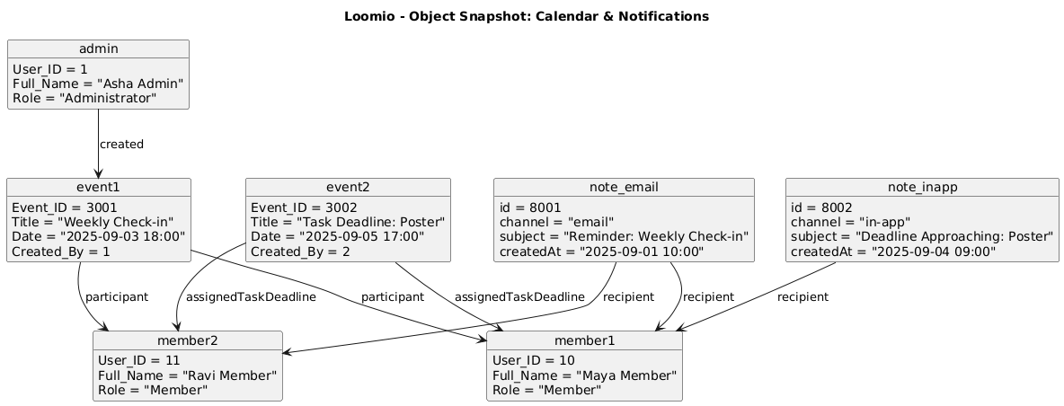**Object Diagram (Calendar & Notifications)**

This snapshot illustrates how events are created by administrators or leaders, assigned to participants, and linked to system notifications. Both email and in-app notifications are used to remind members of upcoming meetings and task deadlines. This diagram reflects the system’s integration of scheduling with communication channels.

**DATAFLOW DIAGRAM**

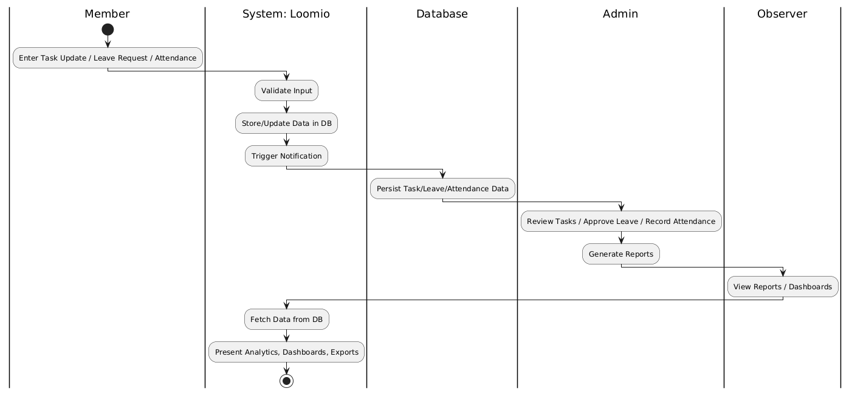

**Activity Diagram - Task Lifecycle**

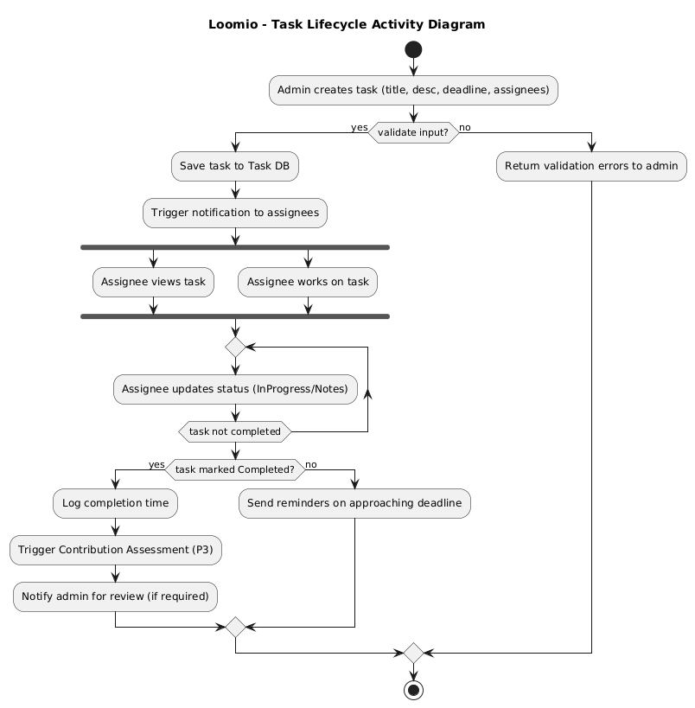

**Activity Diagram - Leave Request & Approval**

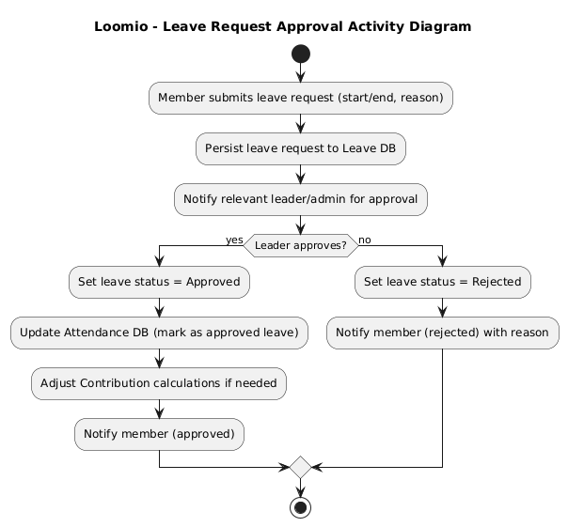

**Activity Diagram - Contribution Points Calculation**

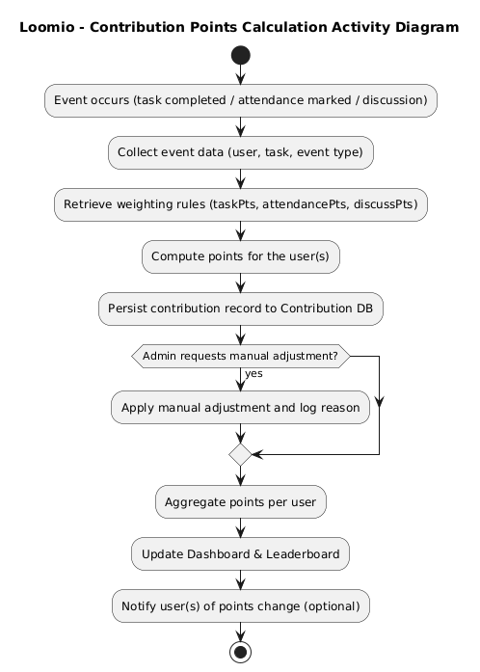

**Activity Diagram - Notification Delivery**

